Software Requirements Specification

for

SecureTrack
Version 1.0 approved
Prepared by Secure Track Group
SecureTrack
2026-02-07

Table of Contents
REVISION HISTORY 2
Section 1: Introduction 2
1.1 Purpose 2
1.2 Document Conventions 2
1.3 Intended Audience and Reading Suggestions 3
1.4 Project Scope 4
1.5 References 4
Section 2: Overall Description and sub sections: 4
2.1 Product Perspective 4
2.2 Product Features (Functions) 5
2.3 User Classes and Characteristics 5
2.4 Operating Environment 5
2.7 Assumptions and Dependencies 6
Section 3: External Interface Requirements 6
3.1 User Interfaces 6
3.2 Hardware Interfaces 7
3.3 Software Interfaces 7
3.4 Use cases modeling deliverables 8
Section4: System Features 10
4.1 Functional Requirements 10
4.2 UML Use Case diagram 12
4.3 High priority use case 12
Section 5: Other Nonfunctional Requirements 14
Section 6: Other Requirements 15
Appendix C: Stakeholder Register 15
Appendix D: Interview Questions 16
Appendix E 18
Class Diagram 18
CRC Cards 18
Gen AI Python code 19

REVISION HISTORY
Name | Date | Reason For Changes | Version
Deliverable 1 | 2026-02-07 |  | V1.0.0
Part B | 2026-03-21 |  | V2.0.0

Section 1: Introduction

1.1 Purpose
This Software Requirements Specification (SRS) document describes the requirements for SecureTrack, a software-based scientific laboratory equipment tracking and theft prevention system. This document covers SecureTrack version 1.0.0.
The purpose of SecureTrack is to control access to scientific laboratories, track laboratory equipment in real time, and prevent unauthorized movement or theft of equipment. The scope of this SRS focuses primarily on the software system, including user management, equipment registration, access control, monitoring, and traceability. Although the system integrates with physical sensors and identification devices, this document specifies only the software requirements and interfaces related to those components, not the hardware implementation itself.

1.2 Document Conventions
The following conventions are/will be used throughout this SRS document:
- Functional requirements are labeled as FRxx (e.g., FR01, FR02).
- Non-functional requirements are labeled as NFRxx (e.g., NFR01, NFR02).
- Requirement priorities are indicated using High, Medium, or Low.
- Headings and subheadings follow a numbered structure for clarity and traceability.
- All acronyms are defined in the table below.
Table of Acronyms
Acronym | Description
SRS | Software Requirements Specification
RFID | Radio Frequency Identification
API | Application Programming Interface
SQL | Structured Query Language

Use case numbering and requirement numbering are consistent across the document to ensure traceability between system features and requirements.

1.3 Intended Audience and Reading Suggestions
This document is intended for the following audiences:
- Software Developers: To understand the functional and non-functional requirements of the system.
- System Architects: To design the overall system architecture and interfaces.
- Project Managers: To plan development tasks and track project scope.
- Laboratory Managers: To understand system capabilities and operational impact.
- Security Officers: To review access control, monitoring, and alert functionalities.
- Testers and Quality Assurance Engineers: To design test cases and validation procedures.
- Academic Evaluators and Instructors: To assess compliance with requirements engineering standards.
Readers are encouraged to begin with Section 1 for context, proceed to Section 2 for an overview of the system, and then review Section 3 for interface-related requirements.

1.4 Project Scope
Scientific laboratories contain valuable and sensitive equipment that require strict access control and traceability. Traditional manual logging methods are error-prone and ineffective in preventing equipment loss or unauthorized usage.
SecureTrack is a software solution designed to address these challenges by providing a centralized system that manages laboratory access, registers equipment, monitors equipment movement, and generates alerts when unauthorized actions are detected. The system enables laboratory administrators to define access rights, approve equipment movement requests, and maintain a complete audit trail of all activities.
The main objectives of SecureTrack are:
- To prevent theft and unauthorized removal of laboratory equipment
- To improve traceability and accountability within laboratories
- To enhance laboratory security through software-driven decision making
- To support institutional goals related to asset protection, compliance, and risk management

1.5 References
- ISO/IEC/IEEE 29148:2018 – Systems and software engineering — Life cycle processes — Requirements engineering
- Radio-frequency identification - Wikipedia/
- What Is an RFID Reader? A Complete Beginner's Guide
- What is Identity Access Management (IAM)? | Microsoft Security

Section 2: Overall Description and sub sections:

2.1 Product Perspective
SecureTrack is a new, self-contained software system developed to support secure laboratory operations. It is not a replacement for an existing system but is designed to integrate with external hardware components such as RFID readers, access sensors, and electronic door locks.
The system operates as a centralized application that communicates with hardware devices through defined interfaces. While SecureTrack may interface with existing institutional systems (such as identity management systems) in future versions, version 1.0.0 operates independently.

2.2 Product Features (Functions)
At a high level, SecureTrack provides the following core features:
- User registration and role-based access control
- Laboratory entry and exit monitoring
- Equipment registration and inventory management
- Equipment movement request and approval workflow
- Real-time detection of unauthorized equipment movement
- Alert generation and incident logging
- Traceability and audit reporting
- Administrative dashboard and system monitoring

2.3 User Classes and Characteristics
The following user classes are expected to interact with SecureTrack:
- Laboratory Users (Students/Researchers): Authorized individuals who access the laboratory and use registered equipment.
- Laboratory Supervisors/Managers: Responsible for approving equipment movement requests and monitoring lab activity.
- System Administrators: Manage user accounts, system configurations, and access permissions.
- Security Personnel: Monitor alerts and respond to security incidents.
Each user class has different access privileges and system responsibilities.

2.4 Operating Environment
The SecureTrack software will operate in the following environment:
- Server Environment: Linux server
- Frontend: Next.js
- Backend Technologies: Node.js
- Database: PostgreSQL
- Web Interface: Compatible with modern browsers such as Google Chrome and Mozilla Firefox
- Network: Secure local network
- Will support mobile interfaces in future versions

2.7 Assumptions and Dependencies
The following assumptions and dependencies may affect the system requirements:
- RFID tags are properly attached to all laboratory equipment
- Sensors and access control hardware are correctly installed and maintained
- Users comply with laboratory access policies
- Stable network connectivity is available
- Third-party APIs and hardware SDKs remain compatible with the system
- Institutional policies permit software-based access control and monitoring

Section 3: External Interface Requirements

3.1 User Interfaces
Users will access SecureTrack through a web-based interface and, optionally, a mobile application.
- Web Interface: Accessible via modern browsers (Chrome, Firefox)
- Mobile Interface: Android and iOS platforms
- Backend Services: RESTful APIs developed using Node.js
The interface will provide role-based access and dashboards tailored to different user classes.
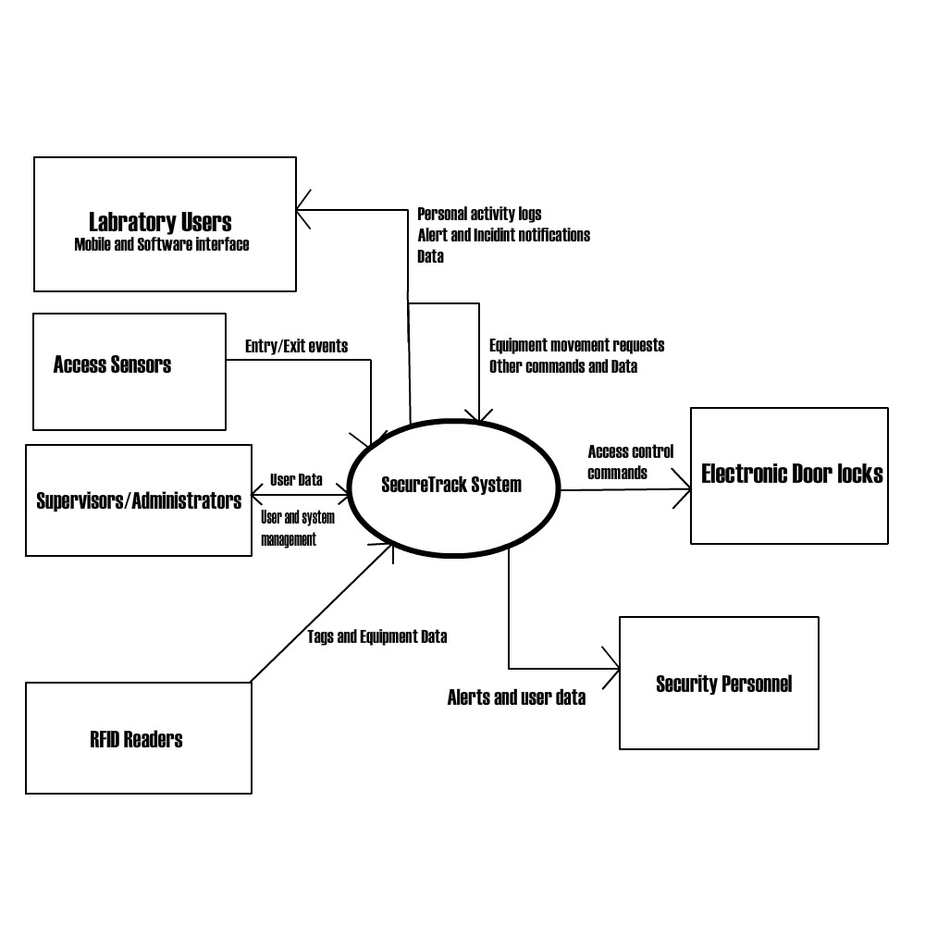

3.2 Hardware Interfaces
SecureTrack interfaces with the following hardware devices:
- RFID readers for user and equipment identification
- Motion and proximity sensors at laboratory entrances
- Electronic door locking mechanisms
These hardware components communicate with the software through predefined interfaces or middleware.

3.3 Software Interfaces
SecureTrack interacts with the following third-party software components:
- RFID reader SDKs (vendor-specific)
- Authentication services or identity management APIs (if integrated)
- Notification services (email or push notification APIs)
Details and documentation links for third-party software are listed in Section 1.5 References.

3.4 Use cases modeling deliverables
Use cases
Use Case name | List of related Requirements ID | Actor (s) | Brief Description
Authenticate user | FR01 | Laboratory user | The actor provides credentials through the system interface. The system validates identity and grants role-based access to system features.
Validate Entry | FR01, FR03 | Laboratory user | When a user approaches the laboratory entrance, the system validates authorization and records the entry event with timestamp.
Record Exit | FRO3 | Laboratory User | The system records user exit events detected by sensors and updates the access log for traceability.
Manage user | FR07 | Laboratory administrator | The administrator creates, updates, deactivates, and assigns roles and permissions to system users.

Equipment tracking and control
Use Case name | List of related Requirements ID | Actor (s) | Brief Description
Register Equipment | FR04 | Lab Administrators | The administrator registers equipment and assigns RFID tags.
Request equipment movement | FR08 | Laboratory User | The user can request to take equipment out of the lab.
Approve Equipment Movement | FR08 | Laboratory manager | The manager approves or rejects equipment movement requests.
Detect Equipment | FR02 | Lab user | When equipment passes through RFID sensors, the system captures the tag ID and matches it to registered records.
Block unauthorized Removal | FR05 | Security Officer | The system prevents unauthorized removal of equipment by triggering alarms.
Generate Audit Log | FR09 | Lab Administrator, Security officer | The system records all equipment movements and activities.

Monitoring and Notification
Use Case name | List of related Requirements ID | Actor (s) | Brief Description
View Dashboard | FR10 | Lab Administrators, lab manager, security officer | Displays real-time system status and activities.
Send alert | FR06 | Security officer | Sends alerts when unauthorized actions occur.
Review-Incident | FR09 | Security officer | Allows review of logged incidents.
Monitor-System-Status | FR10 | IT admin | Monitors system health, performance

Abstract Use case
Use Case name | List of related Requirements ID | Actor (s) | Brief Description
login | FR01 |  | Represents system authentication before accessing features.

Section4: System Features

4.1 Functional Requirements
Functional Requirements list
Requirement ID | Requirement title | Short Description | Priority | Requester
FR01 | User Authentication & Access Control | The system shall authenticate users (staff, students, researchers, administrators) and grant or deny laboratory access based on predefined roles and permissions. Only authorized users shall be allowed to enter restricted laboratory areas. | High | Laboratory Administrator
FR02 | RFID-Based Equipment Identification | The system should identify laboratory equipment using RFID tags when items pass through entry or exit sensors, enabling automatic detection of equipment movement. | High | Lab Manager
FR03 | Entry/Exit Monitoring | The system should record all user entry and exit events through sensor detection, storing timestamps and user identity data for traceability and audit purposes. | High | Security Officer
FR04 | Equipment Registration | The system should allow authorized users to register new laboratory equipment in the system before it is brought into the laboratory, including equipment ID, type, and ownership. | Medium | Lab Technician
FR05 | Unauthorized Removal Detection | The system should detect attempts to remove equipment without proper authorization and immediately trigger an alert and access-blocking mechanism. | High | Security Officer
FR06 | Alert & Notification Management | The system should send real-time alerts (email or push notifications) to administrators when unauthorized access or suspicious activity is detected. | High | Lab Administrator
FR07 | User Management | The system should allow administrators to create, update, deactivate, and assign roles to users within the system. | Medium | System Administrator
FR08 | Access Authorization Requests | The system should allow users to request permission through the application to bring equipment into or out of the laboratory, subject to approval by authorized personnel. | Medium | Research Staff
FR09 | Audit Logs & Traceability | The system should maintain detailed audit logs of user access, equipment movement, and system actions for investigation and compliance purposes. | High | Compliance Officer
FR10 | Administrative Dashboard | The system should provide an administrative dashboard displaying real-time lab status, active users, alerts, and equipment movement summaries. | Medium | Lab Administrator

4.2 UML Use Case diagram
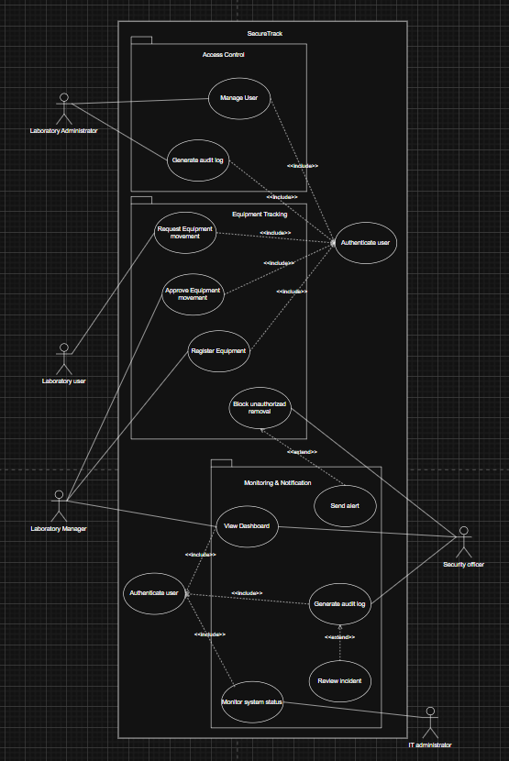

4.3 High priority use case
Use Case: Block-Unauthorized-Removal
Primary Actor: Security Officer
Goal in Context: Ensure that no laboratory equipment leaves the laboratory without proper authorization, maintaining security and accountability of all lab assets.
Preconditions
- Equipment must be registered in the system
- RFID sensors must be active and functional
- User must be identifiable (via system or sensor detection)
Trigger
A laboratory user attempts to exit the laboratory with equipment.
Scenario
- The laboratory user approaches the exit with equipment
- The system scans the RFID tag attached to the equipment
- The system checks whether the equipment is authorized for removal
- If authorization is valid, the system allows the exit
- The system records the transaction in the audit log
Exceptions
If the equipment is not authorized:
- The system triggers an alarm
- The system blocks the exit
- The system sends an alert to the Security Officer
- The system logs the incident
If the RFID tag is not detected:
- The system logs an error
- The system notifies the IT Administrator
Priority
Expected
When Available
The system must always be available during laboratory operating hours
Frequency of Use
High; occurs every time a user exits the laboratory with equipment
Channel to Actor
System dashboard, alerts, and physical alarm system
Secondary Actors: Laboratory User
Channel to Secondary Actors
Physical interaction at entry/exit point and system interface
Open Issues
- Handling cases where RFID tags are damaged, missing, or unreadable
- Defining escalation procedures for repeated unauthorized attempts
- Integration with automated door locking mechanisms
SwimLane Diagram
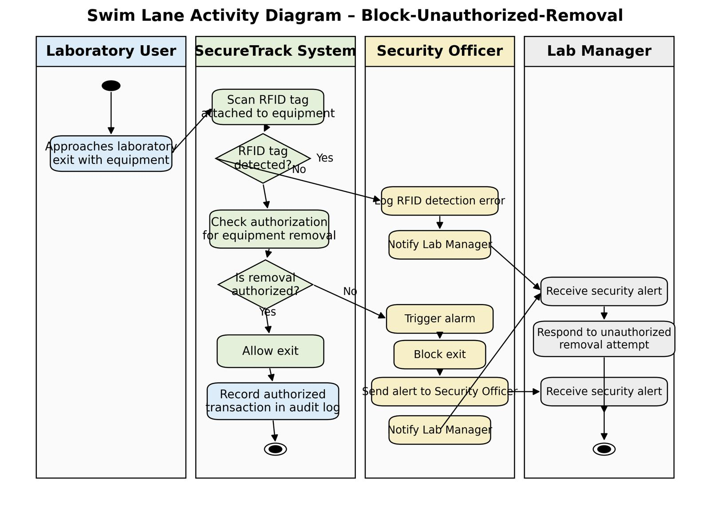

Section 5: Other Nonfunctional Requirements
Functional Requirements list
Requirement ID | Requirement title | Short Description | Priority | Requester
NFR01 | System Security | The system shall implement encryption, secure authentication, and access controls to protect user data and prevent unauthorized system access. | High | IT Security
NFR02 | System Performance | The system shall process sensor events and RFID scans with a response time of less than 2 seconds under Medium operating conditions. | High | IT Administrator
NFR03 | System Reliability &Availability | The system shall be available 99.5% of the time and continue operating during minor hardware or network failures. | High | Lab manager
NFR04 | System Usability | Able to provide a user-friendly interface that is intuitive to navigate. | Medium | End users (researchers, lab managers and administrators)
NFR05 | System Scalability | The system shall support future expansion to additional laboratories, users, and equipment without major architectural changes. | Medium | Programmers
NFR06 | System Compatibility | The system compatible with multiple platforms such as modern web browsers and support integration with RFID reader SDKs and institutional identity management systems. | Medium | IT Administrator

Section 6: Other Requirements

Appendix C: Stakeholder Register
Stakeholder Register
Stakeholder Name | Stakeholder  Position | External/Internal | Stakeholder contact details | Operational/ Executive | Interest  (high, medium, low)
John Smith | Programmer | Internal | Johnsmith@com.ca | Operational | high
Hanna Walts | Marketing | Internal | Hanna@gmail.com | Executive | high
James chuks | Investor | External | Daniel@gmail.com | Executive | high
Jane Won | Lab Administrator | Internal | Jame@gmail.com | Operational | high
Oriana Haide | Researchers | Internal | Oriana@gmail.com | Operational | high
Sam Musa | IT administrator | Internal | Sam@gmail.com | Operational | medium
Prog Mith | IT Security | Internal | Prog@gmail.com | Executive | High
Mike Wonder | Hardware vendor | External | Mike@gmail.com | Operational | low
Brandy | Lab Manager | Internal | Brandy@gmail.com | Executive | High
Rey | Compliance Officer | Internal | Rey@gmail.com | Executive | Medium
Ryan | Security officer | internal | ryan@gmail.com | operational | High

Appendix D: Interview Questions
Interview Questions
Question | Stakeholder position | Answer
How do you typically access the laboratory, and what issues do you face with the current access method? | Laboratory User (Student/Researcher) | We usually use keys or access cards, but access is sometimes delayed or not properly logged.
Do you experience situations where access records are missing or incorrect? | Laboratory User | Yes, sometimes entries are not recorded, which causes disputes.
How is laboratory equipment currently registered and tracked? | Lab Administrator
  Mostly manual logs and spreadsheets.
What approval steps should be required before equipment leaves the lab? | Lab Manager | A formal request and administrative approval.
How should the system respond to unauthorized exit attempts? | Security Officer | Trigger alarms and lock exit doors.
What system features are most important for responding to security incidents? | Security Officer | Real-time alerts and detailed logs.
How frequently should system maintenance occur? | IT Administrator | Regular monthly maintenance with emergency support
What uptime level is acceptable for this system? | IT Administrator | At least 99.5% uptime.
How long should access and equipment logs be retained? | Compliance Officer | At least five years.
Are there institutional policies governing surveillance and access control? | Compliance Officer | Yes, data privacy and access policies must be followed.

Appendix E

Class Diagram
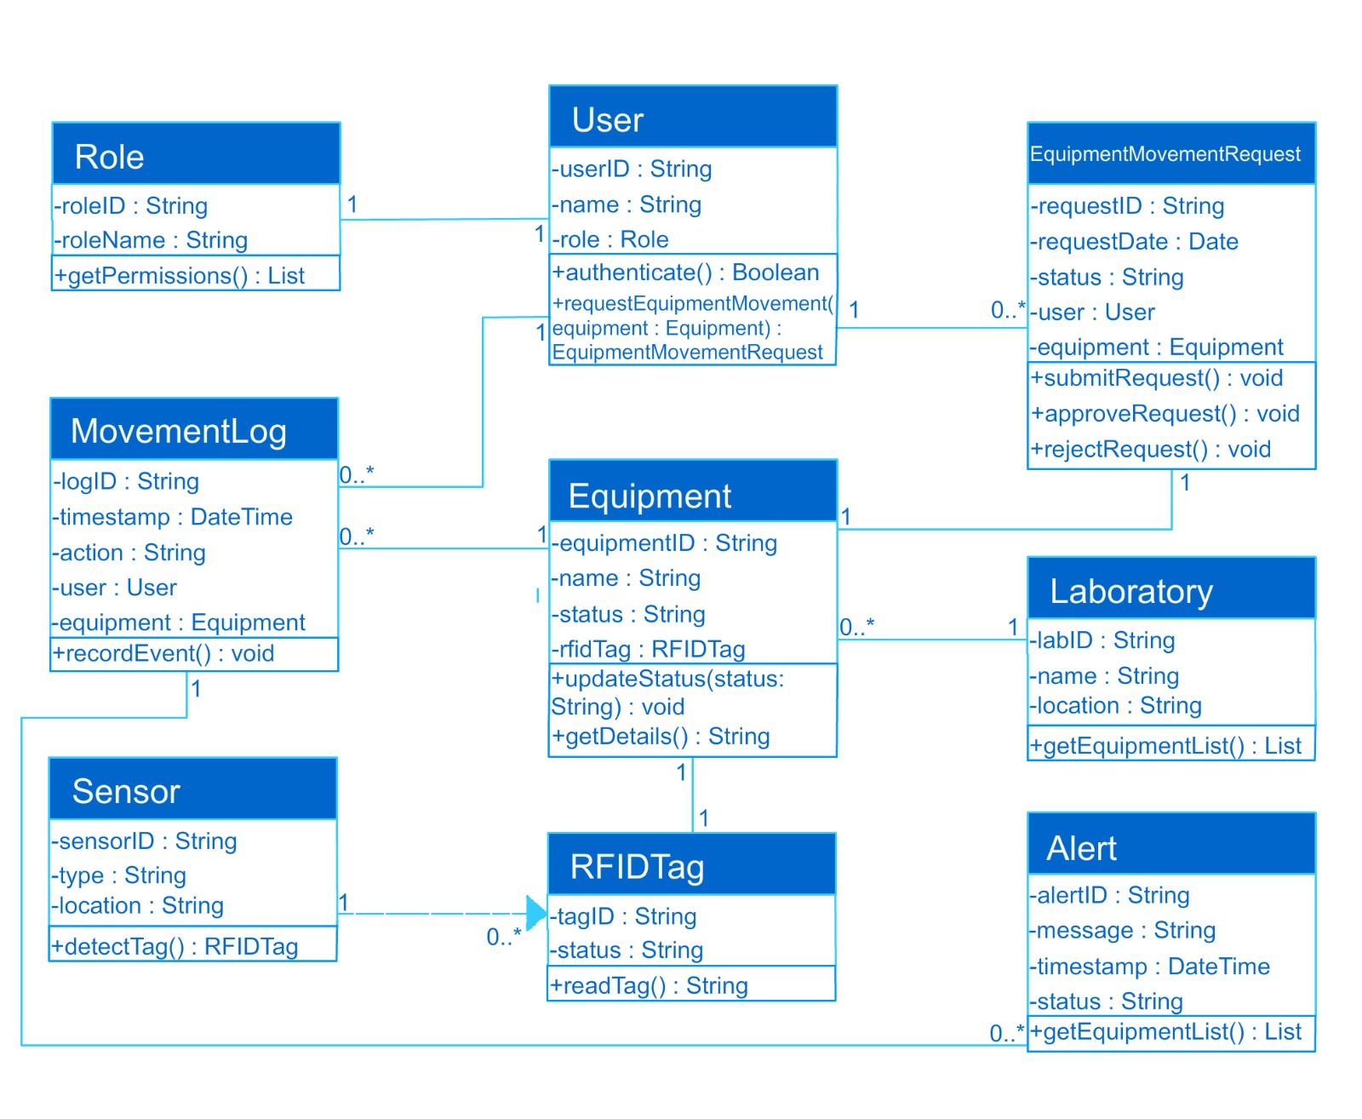

CRC Cards
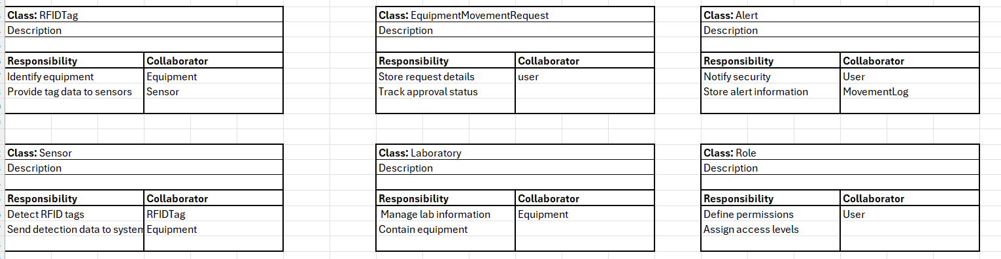

Gen AI Python code
from datetime import datetime

class Role:
def __init__(self, role_id, role_name):
self.role_id = role_id
self.role_name = role_name

def get_permissions(self):
return []

class User:
def __init__(self, user_id, name, role):
self.user_id = user_id
self.name = name
self.role = role

def authenticate(self):
return True

def request_equipment_movement(self, equipment):
return EquipmentMovementRequest("REQ001", datetime.now(), "Pending", self, equipment)

class RFIDTag:
def __init__(self, tag_id, status="active"):
self.tag_id = tag_id
self.status = status

def read_tag(self):
return self.tag_id

class Equipment:
def __init__(self, equipment_id, name, rfid_tag):
self.equipment_id = equipment_id
self.name = name
self.rfid_tag = rfid_tag
self.status = "available"

def update_status(self, status):
self.status = status

def get_details(self):
return f"{self.name} ({self.equipment_id})"

class EquipmentMovementRequest:
def __init__(self, request_id, request_date, status, user, equipment):
self.request_id = request_id
self.request_date = request_date
self.status = status
self.user = user
self.equipment = equipment

def submit_request(self):
self.status = "Pending"

def approve_request(self):
self.status = "Approved"

def reject_request(self):
self.status = "Rejected"

class MovementLog:
def __init__(self, log_id, user, equipment, action):
self.log_id = log_id
self.user = user
self.equipment = equipment
self.action = action
self.timestamp = datetime.now()

def record_event(self):
print(f"{self.timestamp}: {self.user.name} performed {self.action} on {self.equipment.name}")

class Sensor:
def __init__(self, sensor_id, location):
self.sensor_id = sensor_id
self.location = location

def detect_tag(self, equipment):
return equipment.rfid_tag.read_tag()

class Alert:
def __init__(self, alert_id, message):
self.alert_id = alert_id
self.message = message
self.timestamp = datetime.now()
self.status = "New"

def send_alert(self):
print("ALERT:", self.message)

class Laboratory:
def __init__(self, lab_id, name, location):
self.lab_id = lab_id
self.name = name
self.location = location
self.equipment_list = []

def get_equipment_list(self):
return self.equipment_list

